EXPANSION FOR BATTERY RECYCLING COLLECTION PROGRAM
In addition to the rechargeable & button battery recycle program, Cranbury Township now collects household/single use batteries in Town Hall, DPW Office.

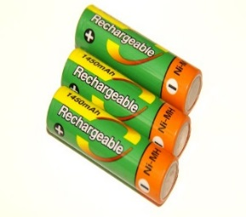
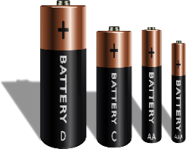
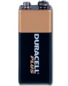
- HOUSEHOLD/SINGLE USE BATTERIES: A dedicated recycling collection box is located in Town Hall, DPW Office to collect AA, AAA, C, D, and 9 volt batteries. Toss all leaky and corroded batteries into the trash. They cannot be recycled or mailed.

- RECHARGABLE & BUTTON BATTERIES can be brought to Town Hall, DPW Office. These include power tools, all cellphones, laptop batteries, button batteries and rechargeable batteries.
- A battery must weigh less than 11 pounds.

Battery ends must be sealed with tape or placed in a tightly bound plastic bag so the ends do no touch. This step will prevent exposed ends from touching during the shipping process and will prevent sparking a possible fire.
Please note household/single use and rechargeable batteries must be deposited into different boxes. Do not commingle them, keep them separated!!!
Media e-waste (CDs, DVDs, VHS tapes are limited to 25 per household), cell phones, button, household and rechargeable batteries can be dropped off in the DPW office at Town Hall, during business hours. Due to the cost of these programs, service is available for Cranbury residents only.

ALL DROP-OFF RECYCLE PROGRAM BOXES ARE LOCATED IN THE DPW OFFICE WITHIN TOWN HALL.

